**Hotel Cancellations Problem**

In recent years, City Hotel and Resort hotel have seen cancellations rates. Each hotel is now dealing with several issues as a result, including fewer revenues and less than ideal hotel room use. Consequently, lowering cancellation rates is both hotels’ primary goal in order to increase their efficiency in generating revenue, and for us to offer thorough business advice to address this problem.

The analysis of hotel booking cancellations as well as other factors that have no bearing on their business and yearly revenue generation are the main topics of this report.



**Assumptions**

1. No unusual occurrences between 2015 and 2017 will have a substantial impact on the data used.
2. The information is still current and can be used to analyze a hotel’s possible plans in an efficient manner.
3. There are no unanticipated negatives to the hotel employing any advised technique.
4. The hotels are not currently using any of the suggested solutions.
5. Biggest factor affecting the effectiveness of earning income is booking cancellations.
6. Cancellations result in vacant rooms for the booked of time.
7. Clients make hotel reservations the same year they make cancellations.

**Objective of the analysis**

1. What are the variables that affect hotel reservation cancellations?
2. How can we make hotel get lesser cancellations?
3. What is the main cause of hotel booking cancellations?

**Initial Hypothesis**

1. More cancellations occur when prices are higher.
2. When there is a long waiting list, customers tend to cancel more frequently.
3. Most clients are coming from offline travel agents to make their reservations.

**Analysis and Findings**

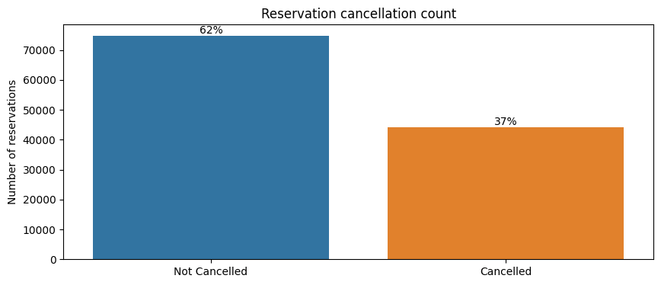

As shown in the bar plot, almost 37% of bookings get cancelled. It seems that there is some factor affecting the cancellation rate cause 37% cancellation rate is a high cancellation rate. This must be affecting the revenue of these hotels significantly.

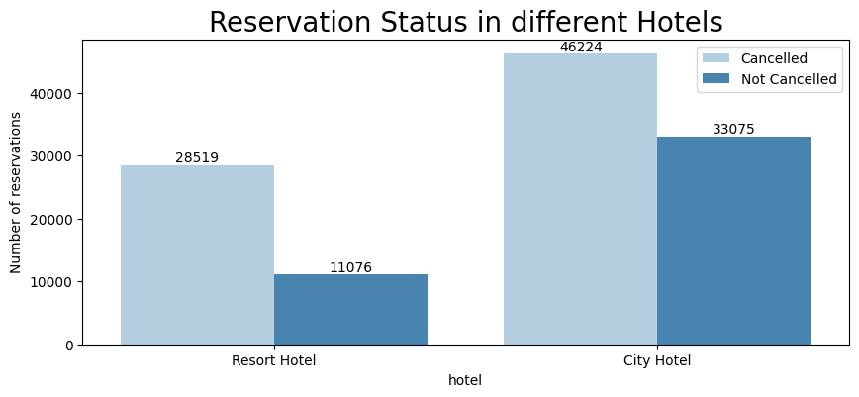

From the above plot, we can concur that City Hotels are generally getting more bookings and Resort Hotels are lesser bookings. The reason for this could be that Resort Hotels are usually more expensive than City Hotels and people in usually want to spend less amount of money.

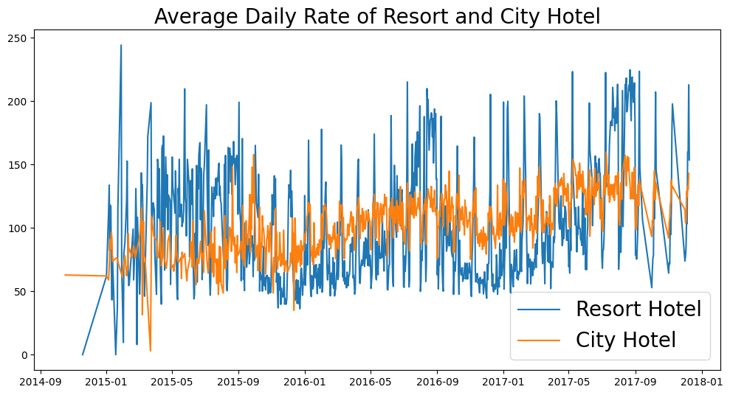

The above plot shows that, on an average, City Hotels charge less than Resort Hotels. Also, City Hotels do not have drastic changes in their rate but Resort Hotels seem to have high fluctuations. These types of fluctuations might not be liked by some customers, if a customer sees that they could book the same Resort Hotel for cheaper at some time later in the future, they are more likely to cancel their current booking.

During holiday season, the prices are prone to get high too.

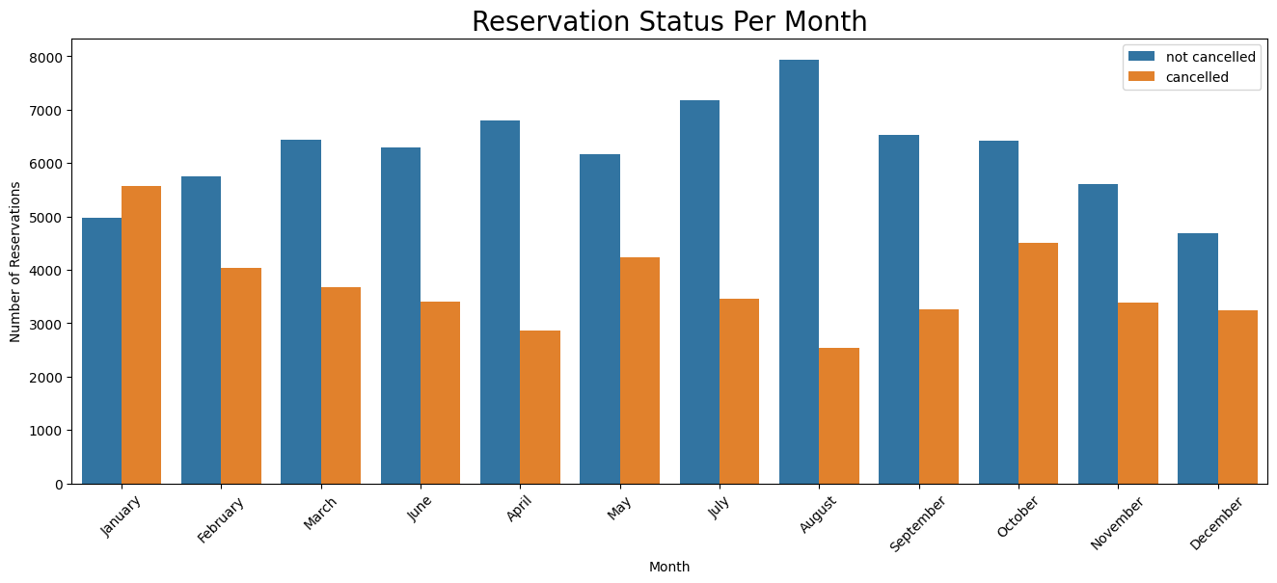

We wanted to check which months seem to have the highest cancellations for that we created a bar plot showing us the reservation status per month. We have the highest bookings in the month of August and January has the greatest number of cancellations.

This could be because a lot of people plan on travelling during the new year period but tend to not go along with their reservations due to unforeseen reasons.

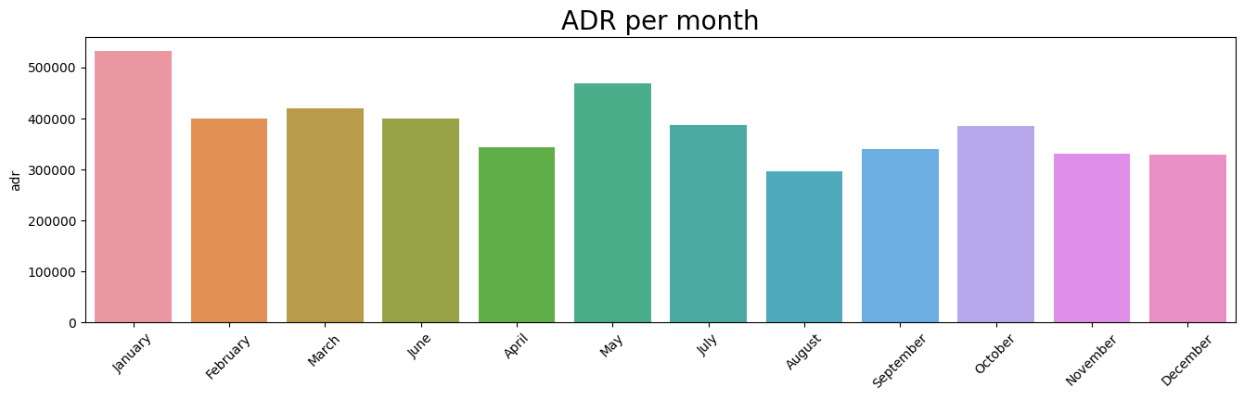

This plot shows us the Average Daily Rate of hotels and it seems to be high during the month of January that could be contributing towards higher cancellation rate as people tend to not go ahead with expensive bookings.

This is proven when we look at the data for August, which has the Average Daily Rate as the lowest out of all the months and the highest number of bookings, moreover, August also has the lowest number of cancellations.

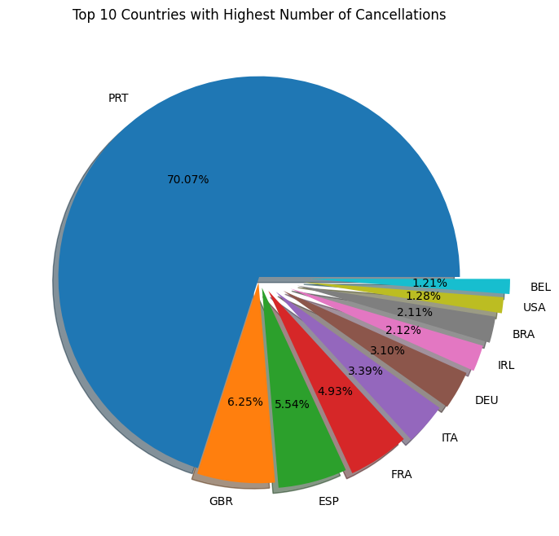

The pie chart shows that Portugal has the highest cancellation rate when it comes to bookings. Other countries have significantly low cancellation rate when compared with Portugal.

This suggests that the data for Portugal show be observed closely and we should try to find out the reason for so many cancellations from a specific region.

It could be that the services provided in hotels that in Portugal are not good, people tend to focus a lot on hygiene when it comes to hotel booking.

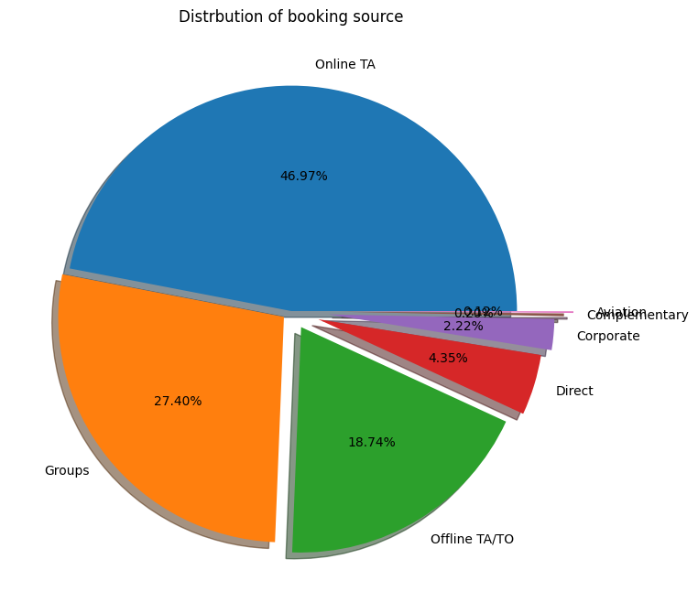

Our Pie chart shows that almost half (46.97%) of the cancellations come from Online Travel Agents. Since the bookings are online, there tends to be more cancellations because it is just a click away and there tends to less repercussions like “no questions asked cancellations”.

One reason for high cancellations could also be that the Online Travel Agents are not providing the correct information about the hotels such as fake/false images, facilities like wifi or closest public transport, etc.

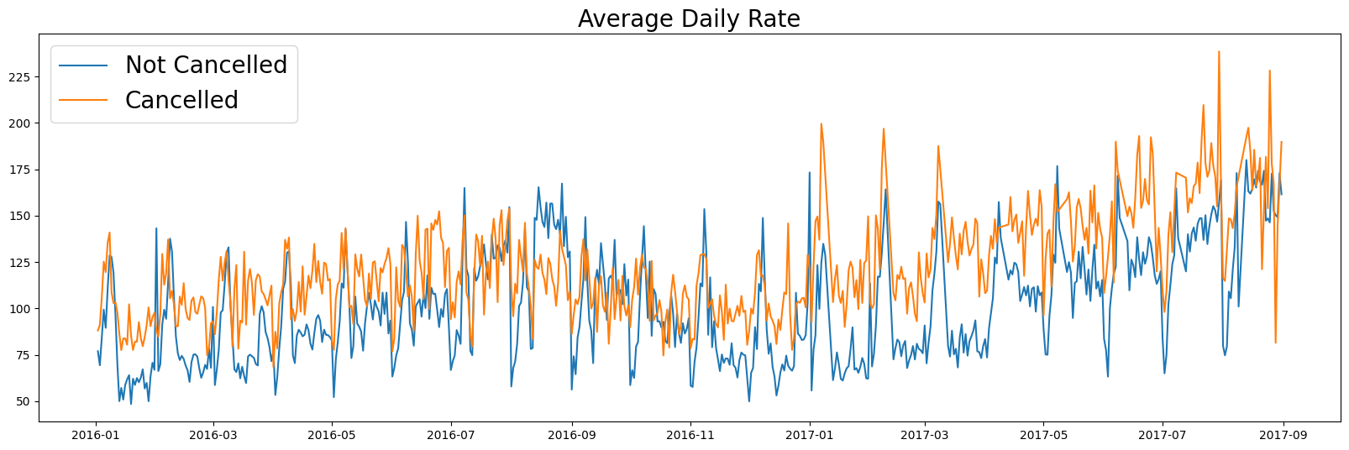

We can see from the above line chart that Average Daily Rate for Cancelled bookings is high than not cancelled bookings.

It seems that high price is a reason for higher cancellations.

**Conclusion**

1. Cancellation rate rises as the price of the hotel rises. In order to prevent cancellations, hotels should work out some new pricing strategies and try to lower the rates for specific hotels based on locations.
2. As the ratio of the cancellation and no cancellation of the Resort Hotel is higher, the hotels could provide discounts on room prices on weekends or holidays.
3. One way to decrease cancellation could be to give vouchers or gift cards that can be used in the future, this way even if the prices are high the customer still feels that they are getting better returns.
4. Before the month of January, hotels can start ad campaigns or use other marketing strategies to increase the revenue as the cancellation is highest during this period.
5. They should also increase the quality of services provided, the infrastructure of the hotels in Portugal as there is high cancellation rate there.